



REGISTER '/home/acadgild/airline_usecase/piggybank.jar';

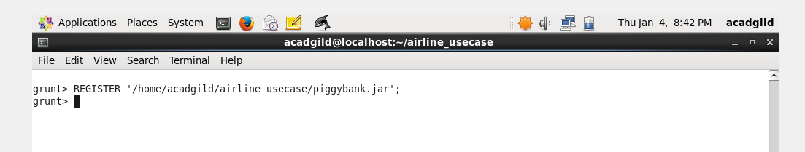

A = load '/home/acadgild/airline_usecase/DelayedFlights.csv' USING org.apache.pig.piggybank.storage.CSVExcelStorage(',','NO_MULTILINE','UNIX','SKIP_INPUT_HEADER');

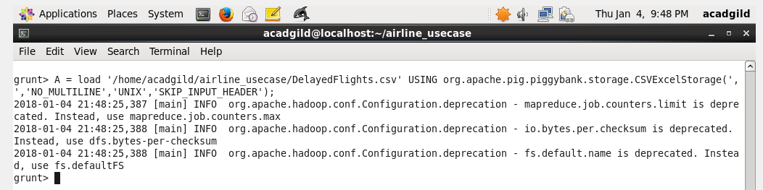

B = FOREACH A GENERATE (chararray)$17 as origin, (chararray)$18 as dest, (int)$24 as diversion;

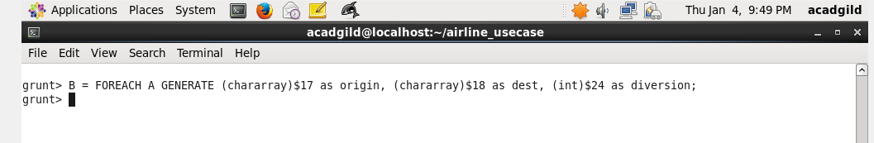

C = FILTER B BY (origin is not null) AND (dest is not null) AND (diversion == 1);

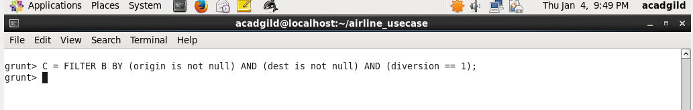

D = GROUP C by (origin,dest);

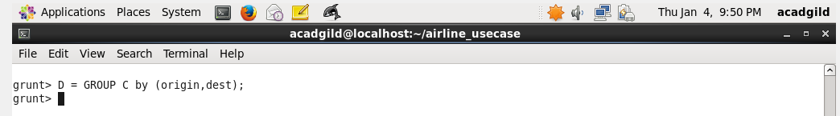

E = FOREACH D generate group, COUNT(C.diversion);

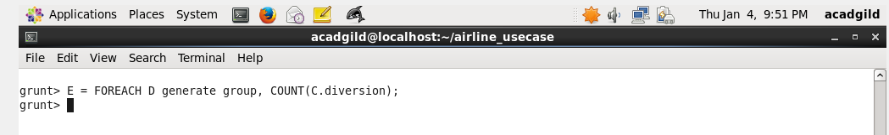

F = ORDER E BY $1 DESC;

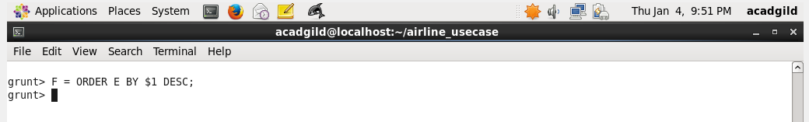

Result = limit F 10;

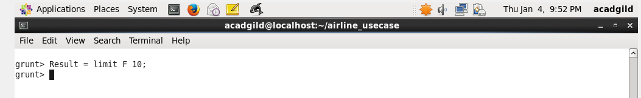

dump Result;

